List of images

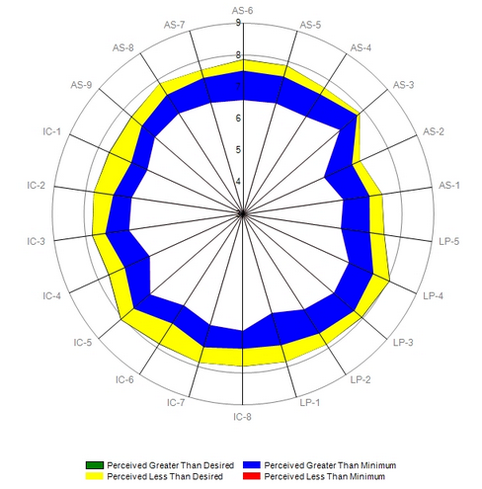
Figure 1: The 2016 LibQUAL Radar Chart for the Georgia Southern University Library

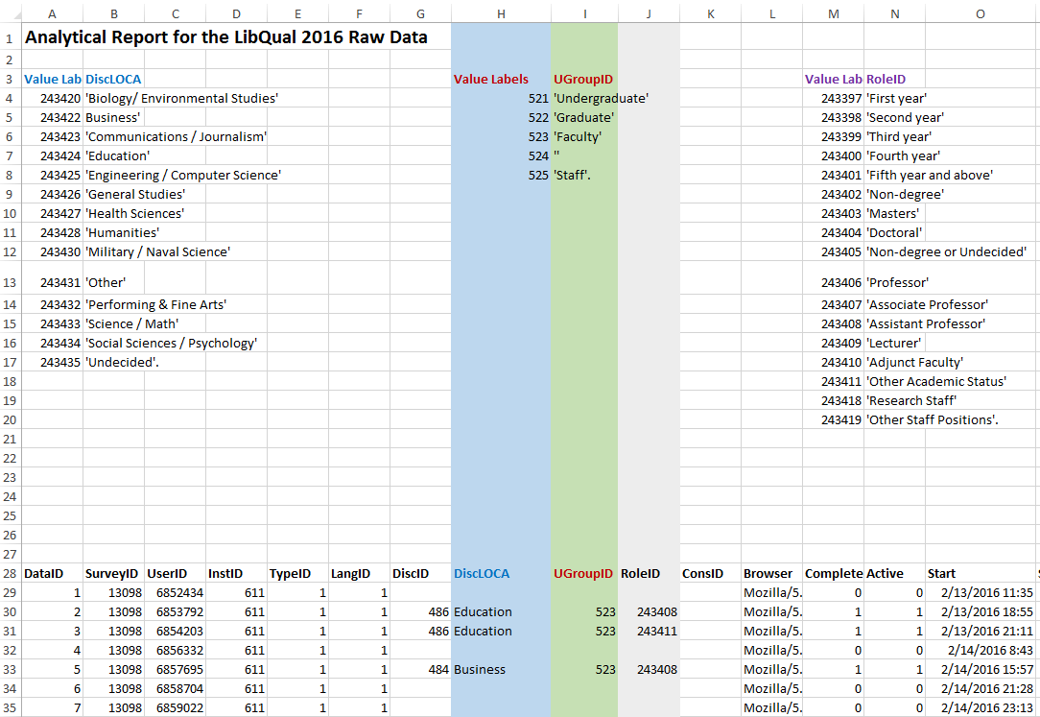
Figure 2: 2016 LibQUAL Survey Raw Data for Georgia Southern University Library

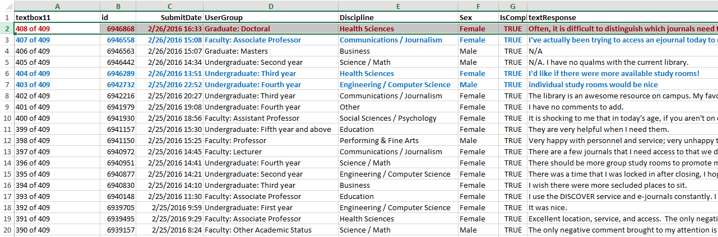
Figure 3: 2016 LibQUAL User Response Raw Data for Georgia Southern University Library

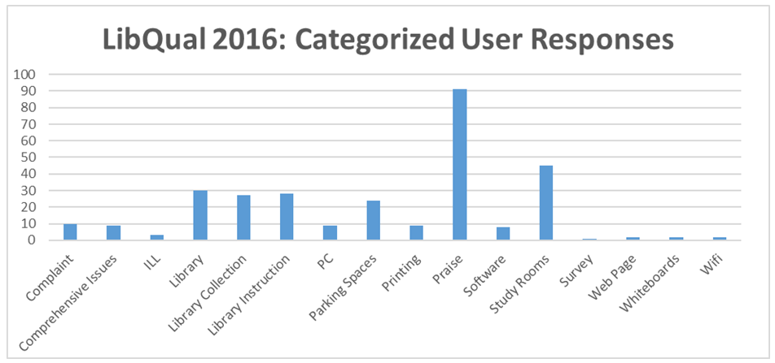
Figure 4: Categorized User Responses in 2016 LibQUAL Survey

